JAVA PROJECT

NAME : POOJASREE.K

REG NO : 231401075

DEPARTMENT : CSBS-B

**Step 1:**

It is Login page. If suppose we don’t have an account means Click Signup button then it goes to signup page.

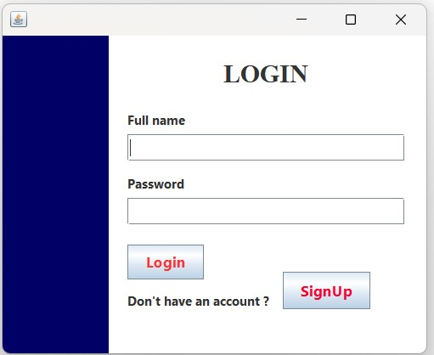

**Step 2:**

SignUp Page. Here we have to signup by entering username , email , password.

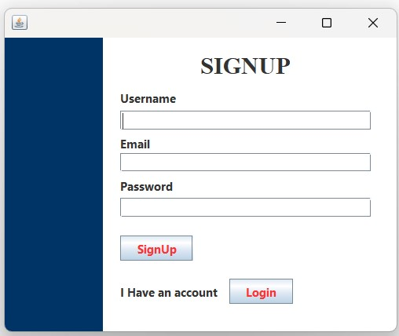

**Step : 3**

After entered all, Click signUp Button to Singing In.

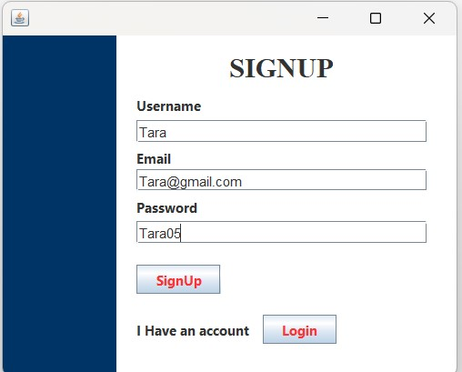

**Step 4:**

Displays the message “Account Created Successfully”

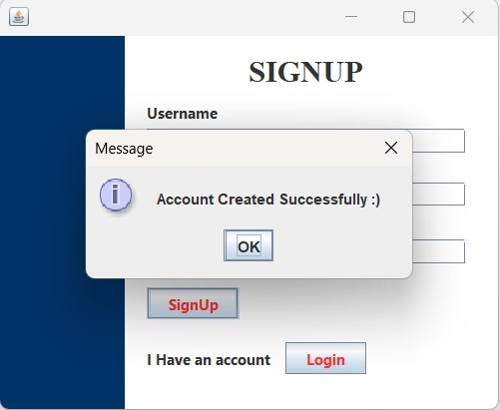

**Step : 5**

Database(MySQL) before adding new user.

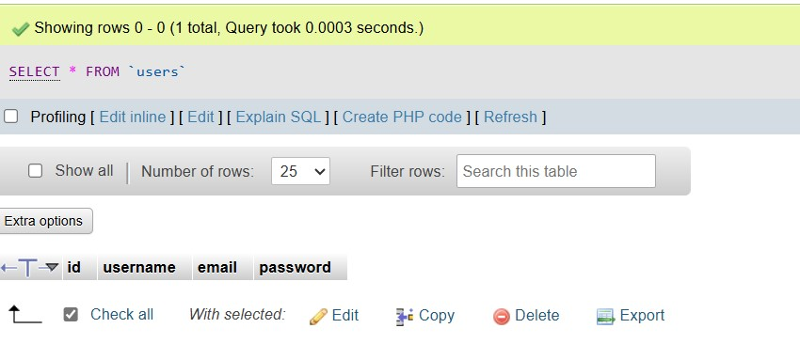

**Step 6:**

Database (MySQL) After adding new user.

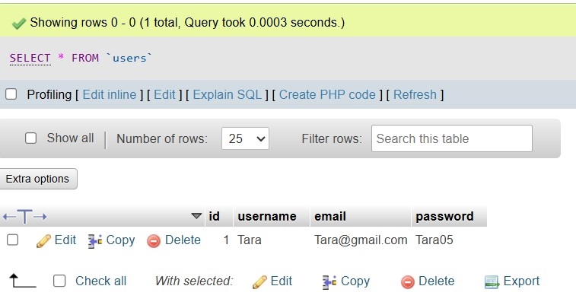

**Step 7:**

It goes to Home Page after signing in.

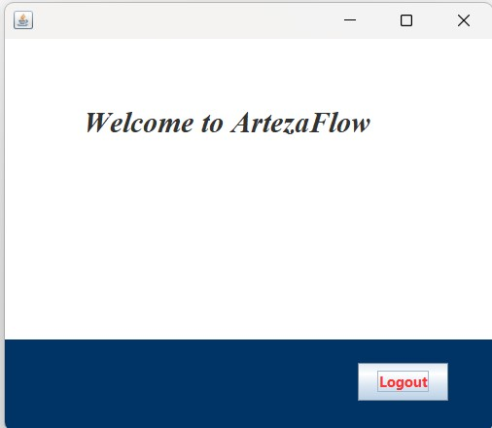

**Step : 8**

Again we use same username to check whether it is logged in . And Hence it displays the message login successfull.

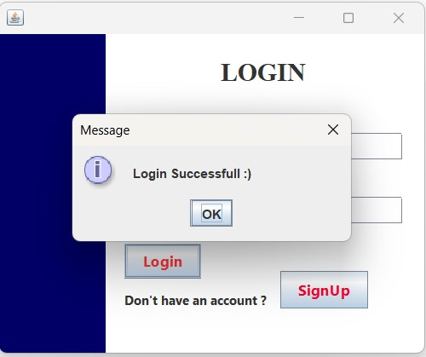

**Step 9:**

It goes to the Home Page. If we need to logout we can give the logout button.



**Step 10:**

If we enter any incorrect username or password , we get error message .

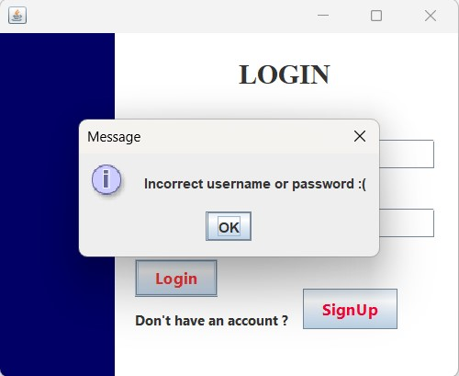

**Step 11:**

It Again goes to the login Page.

